Want to Join Flicks in the Sticks?

Flicks in the Sticks is a part of Arts Alive which is a registered Charitable Trust.
We rely on public investment to be able to continue to tour films to village halls throughout the two counties, and this public investment is of course getting less!
If you are thinking of holding a Flicks in the Sticks night read on!

Do you have your own Cinema equipment installed in your village hall?

See Notes 1. We can book film rights, and undertake publicity for you.

No Yes
Is your venue based in Shropshire or Herefordshire

See note 2. We have a waiting list at the moment. Fill in the form and we will see what we can do
Yes

No
See note 3.We may be able to come to your venue but we have to charge a more commercial rate.

1. Independent Flicks Promoter
If you have all the necessary equipment to do the screenings yourself, you could become what we call an ‘independent’ promoter. You could apply on this basis at any time and the cost per screening would be £83 or 35% of the box office, whichever is the greater, plus a £10 booking fee including VAT (unless you are VAT registered then it is plus VAT).

We would book the film rights and publicise your screening on our website and you would do the rest e.g. local publicity, obtaining a copy of the film on DVD/blu-ray and showing the film yourself. We would give you login details to our website, where you will find a host of film finding resources and where you will complete your audience return after the screening.

2. Regular Flicks Promoter (where our technician brings the equipment and screens the film)

For venues within the Counties of Shropshire and Herefordshire
Places on the Flicks in the Sticks scheme are limited, due to funding restrictions. if you would like your hall to be placed on our waiting list, please fill in the form below and we’ll see what we can do. We do get gaps from time to time, so it may be possible to arrange something – or at least a trial.
Where we receive an application from a venue within 5 miles of an existing venue, it is our policy to contact the promoter to ask their thoughts and see what concerns they have, if any, before we consider the application. Where promoters are located close to each other, we expect promoters to work together regarding dates and film selection.

3. Other Flicks Services

If you don’t fit into one of the categories above i.e. if you don’t have your own screening equipment and you’re not in Shropshire or Herefordshire.
We have to charge a more commercial rate for screenings outside of Shropshire and Herefordshire, where you don’t have your own equipment. As you will appreciate it is quite costly sending a technician, paying for the upkeep of the equipment and paying the film rights which can cost £100.
Please see map on following page to give you an approximate idea of the costs involved.

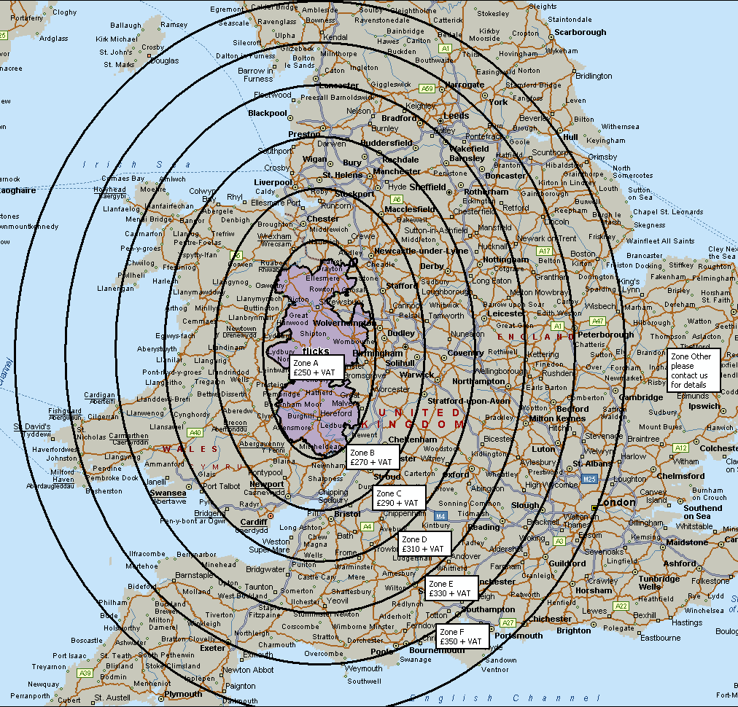
Map of Zone Charges

Flicks Promoter Application Form

Proposed Promoter Name: ……………………………………………………………………………………………………

Address of Promoter: ……………………………………………………………………………………………………………

………………………………………………………………………………….. Postcode: …………………………………….
Tel No: …………………………………….………... Mob No: …………………………………………………………....
Email address: ……………………………………………………………………………………………………………………

Please tick as appropriate, are you applying as:
A member of a committee An Individual Or a member of a group

Name of Committee or Group: ………………………………………………………………………………………………

Venue Name: ………………………………………………………………………………………………………………………

Venue Address: ……………………………………………………………………………………………………………………

………………………………………………………………………………. Venue Postcode: …………………………….

Village Website address: ………………………………………………………………………………………………………

Venue District/Local Council: …………………………………………………………………………………………………

Is the venue VAT Registered? Yes / No

Please give your main reason for wanting to have Flicks screenings at your venue: ……………………

……………………………………………………………………………………………………………………………………………

……………………………………………………………………………………………………………………………………………

Are you applying as:

• an ‘independent’ venue (one which has its own screening equipment)

• or a venue to be ‘toured to’ (our technician and equipment come to you)

Is the electricity run on a meter? …………………………………………………………………………………………..

Are there obstacles that may affect projection equipment e.g. pillars/hanging heaters? If so, please give details:
……………………………………………………………………………………………………………………………………………

……………………………………………………………………………………………………………………………………………

Page 1
Flicks in the Sticks Promoter Application Form - continued

Dimensions of your venue (in metres please):

Height: ………………………. Width: …………………………. Length: …………………………….

What is the seating capacity? (this will be on your premises licence) …………………………………………

Does your venue have blackout? Yes / No If yes, please state type: …………………………….

……………………………………………………………………………………………………………………………………………

Would you be happy for us to sell tickets on your behalf from our website? Yes / No

Signed: ……………………………………………………………………….. Date: ……………………………………….

Please draw out a basic floor plan on a separate piece of paper indicating access points and
position of electric sockets:

If possible please obtain a digital photo of the outside & inside of your venue and send with your application.

Please email your completed application form to: terri@artsalive.co.uk
or please post to:
Arts Alive, Office 007 Enterprise House, Station Street, Bishops Castle, Shropshire, SY9 5AQ

Thank you

web: www.artsalive.co.uk Tel: 01588 620883

